Electric Lift Troubleshooting
Is your platform too low?

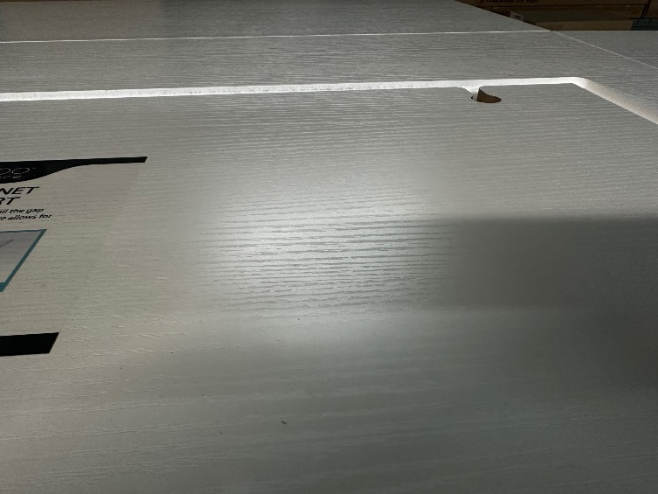
If you notice your platform is too low, you will need to adjust it to allow your sewing machine to sit flush with the opening.
First, you’ll need to lower the platform so the white tab is showing.
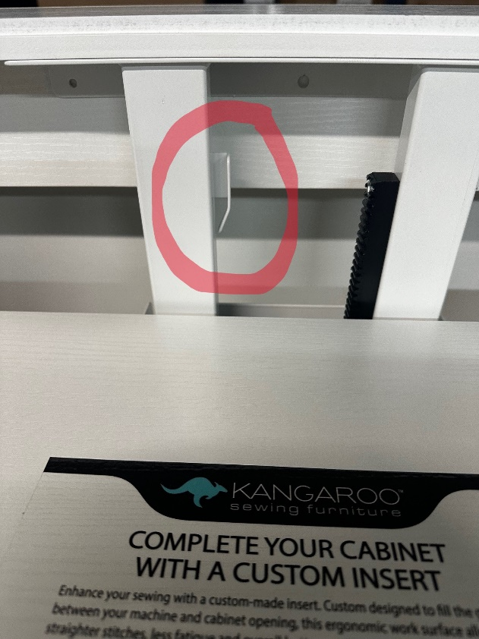
Next, you’ll need a pair of needle nose pliers. Use the pliers to bend the tab GENTLY towards the white bar to allow it to bring the platform higher. If you need to lower the platform, you will bend the tab back out to the desired location. NOTE: If you are too aggressive with the bending of the tab it may cause the tab to loosen from the screws securing it in the back. Try to be firm yet gentle when applying the pressure to bend the tab. You do not want the tab to become wobbly.
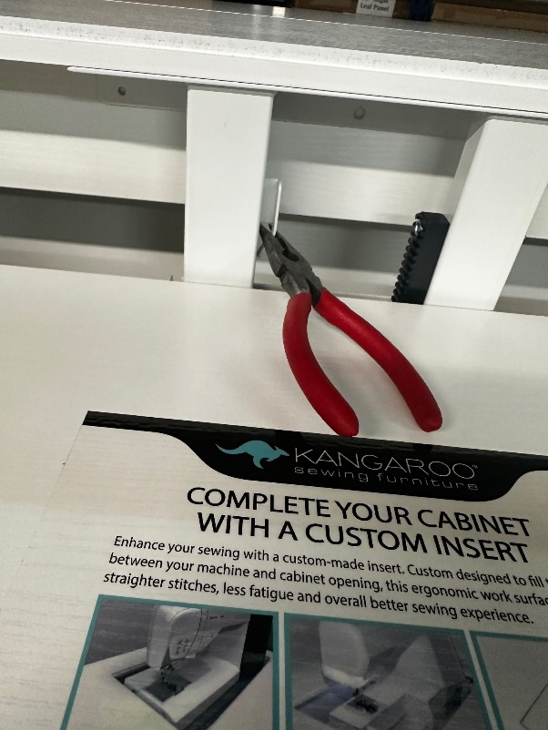
This process takes patience as it may take a couple of tries until you get your platform flush with the cabinet. Start small with your bends, a little bend is all you will need to get your platform where it needs to be. Here is what a flush platform looks like:
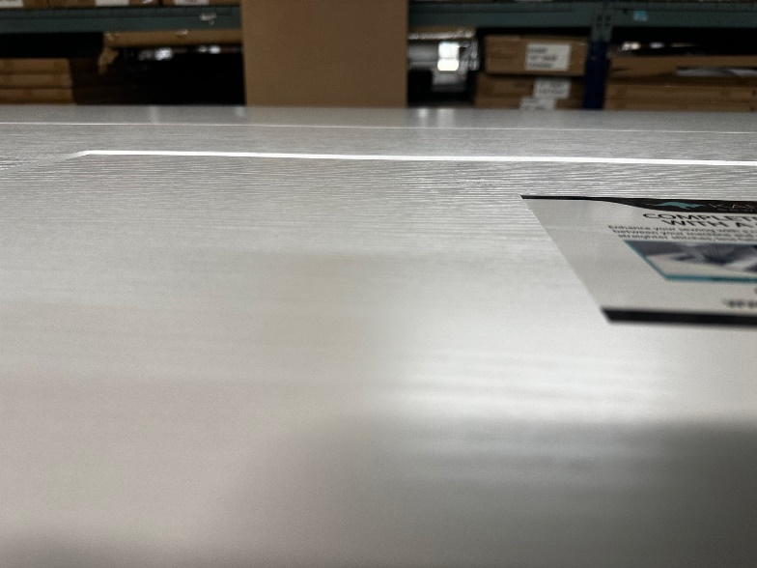
After achieving the back of your platform to be level and flush, you may notice the front end is lower or higher now.
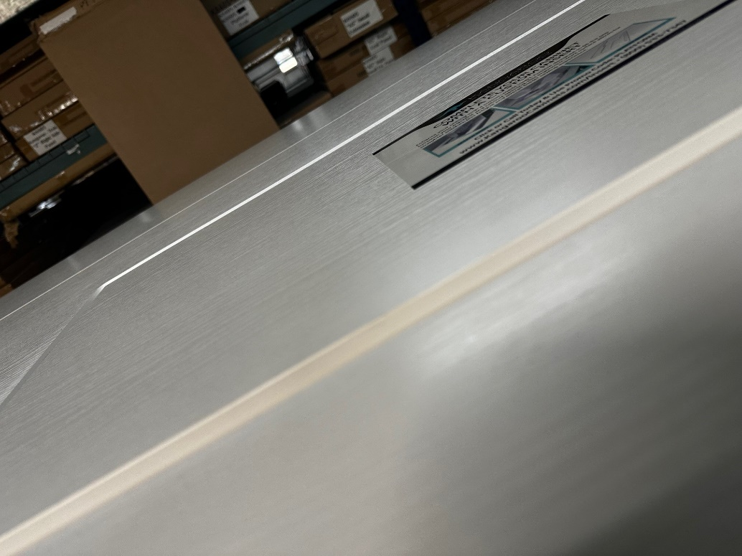

You will need a ½ socket wrench and a ½ size wrench. We will be looking under the platform now and working with 6 nuts, 3 on each side.
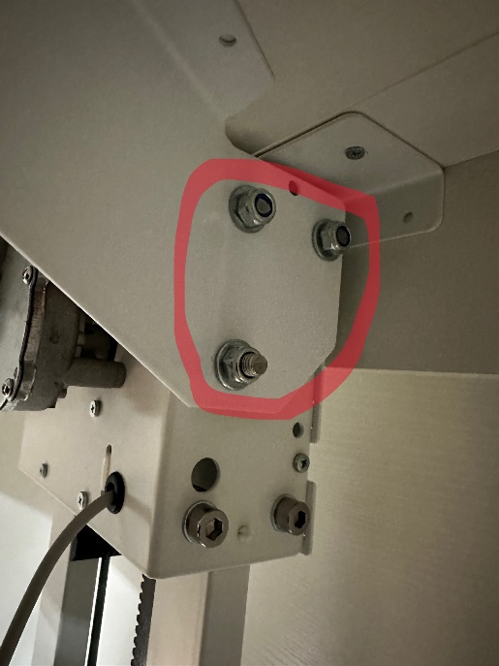

Place your socket wrench on the outside nuts. Loosen all 6 nuts SLOWLY and only until you feel it give. YOU ARE NOT LOOSENING THE NUTS ALL THE WAY.
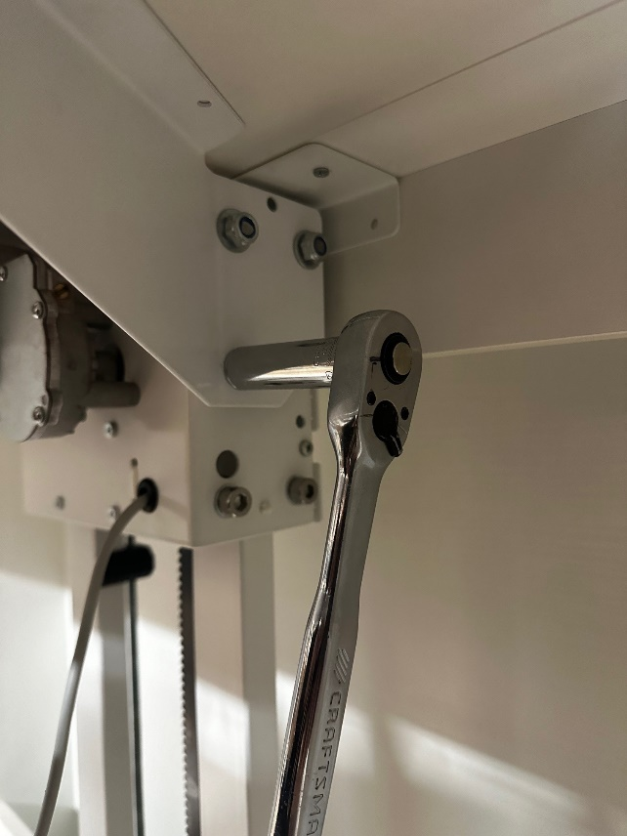
Loosening these nuts allow you to move the “wings” so that the platform will be flush. Gently but firming move the wings up or down with your hands to allow your platform to sit flat and flush. You can push down on the top of the platform is that is easier for you as well.
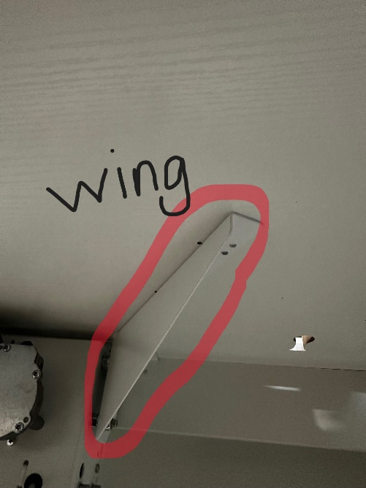

Once you get your platform to your desired position you will tighten the nuts back up. Using the ½ socket wrench and the ½ size wrench. You will place the wrench on the inside nut and the socket wrench on the outside nut. You want to hold the inside nut tight with the ½ size wrench so it does not move. Tighten outside nut with socket wrench.
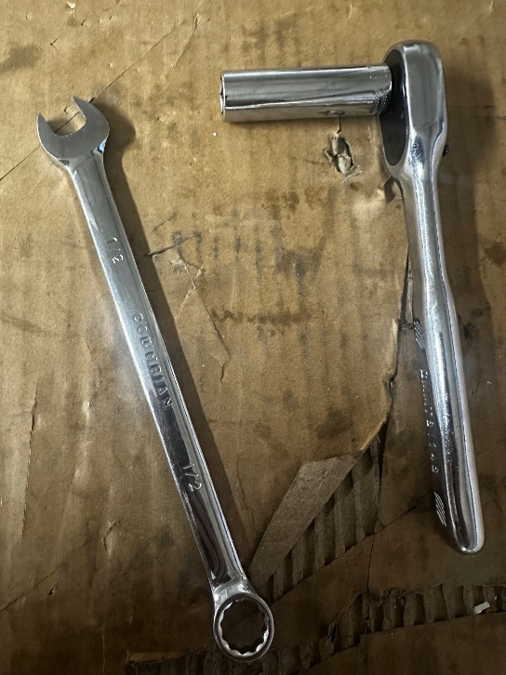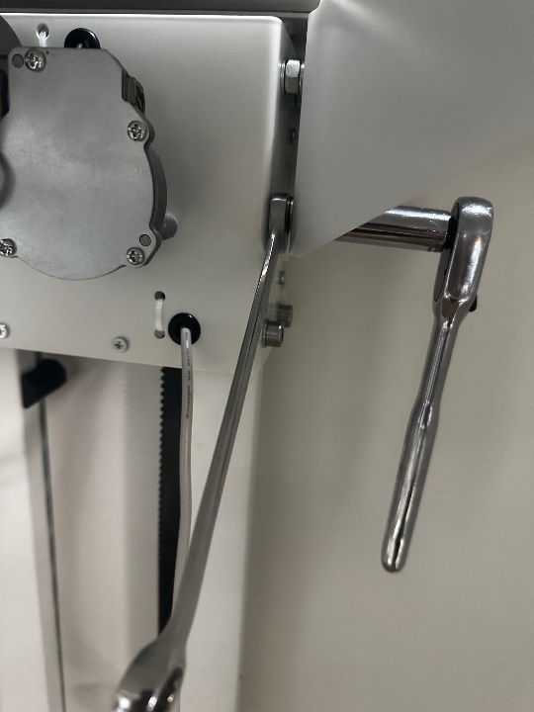
Your platform should now be level and tightened. Happy Sewing!
